Grade 7 Accelerated · Unit 6 · Lesson 5  Distance on the Coordinate Plane  Independent Set 6.05 | Name______________________  Date______________________  Period____________________

Six questions, on your own, in silence. Show the step that does the work.
1. Find the distance between 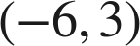 and 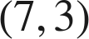.

2. Find the distance between 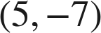 and 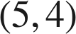.

3. Find the distance between  and 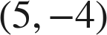.

4. Find the distance between 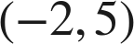 and 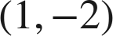, to the nearest tenth.

5. How far is  from the origin, to the nearest tenth?

6. On a map in kilometers, a pool is at 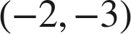 and a park at 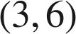. How far apart are they in a straight line, to the nearest tenth of a kilometer?

